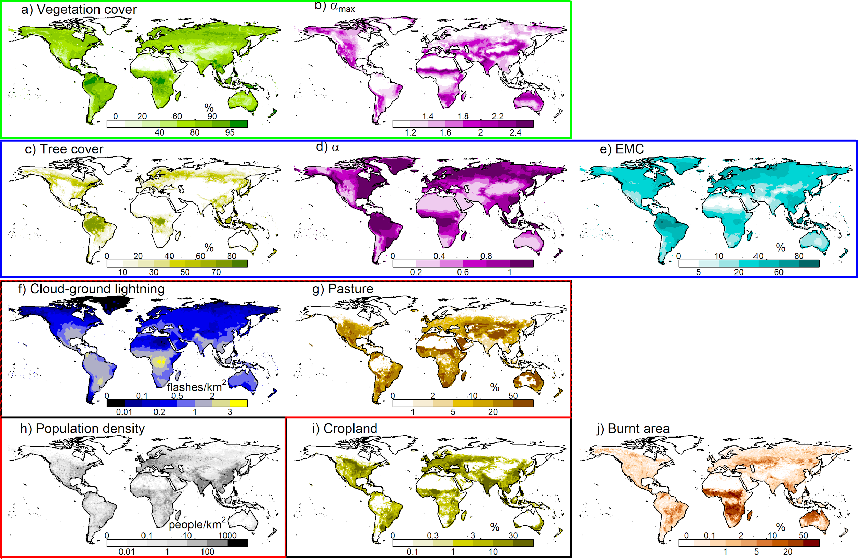

**Supplementary Figure 1: Mean annual values for the variables used to reconstruct burnt area.** Green box contains variables used to describe fuel continuity control: a) total percentage vegetation cover [1](https://paperpile.com/c/JkHL33/vhid); b) annual maximum monthly actual over potential evapotranspiration ($α_{max}$) calculated using the SPLASH model [2](https://paperpile.com/c/JkHL33/SMGM). Blue box contains variables used for fuel moisture: c) percentage tree cover [1](https://paperpile.com/c/JkHL33/vhid); d) mean annual actual over potential evapotranspiration () [2](https://paperpile.com/c/JkHL33/SMGM); e) equilibrium moisture content (EMC) calculated as per [3](https://paperpile.com/c/JkHL33/zgKW). Red box contains variables used for ignitions: f) number of lightning flashed from LIS [4](https://paperpile.com/c/JkHL33/hF0E) corrected for cloud-to-ground strikes following [3](https://paperpile.com/c/JkHL33/zgKW); g) percentage pasture cover [5](https://paperpile.com/c/JkHL33/eel1); f) population density [5](https://paperpile.com/c/JkHL33/eel1). Black box contains variables used for anthropogenic suppression which, in addition to f), includes g) percentage cropland cover [5](https://paperpile.com/c/JkHL33/eel1). h) is the mean annual burnt area [6](https://paperpile.com/c/JkHL33/fQ08) the framework is optimized against.

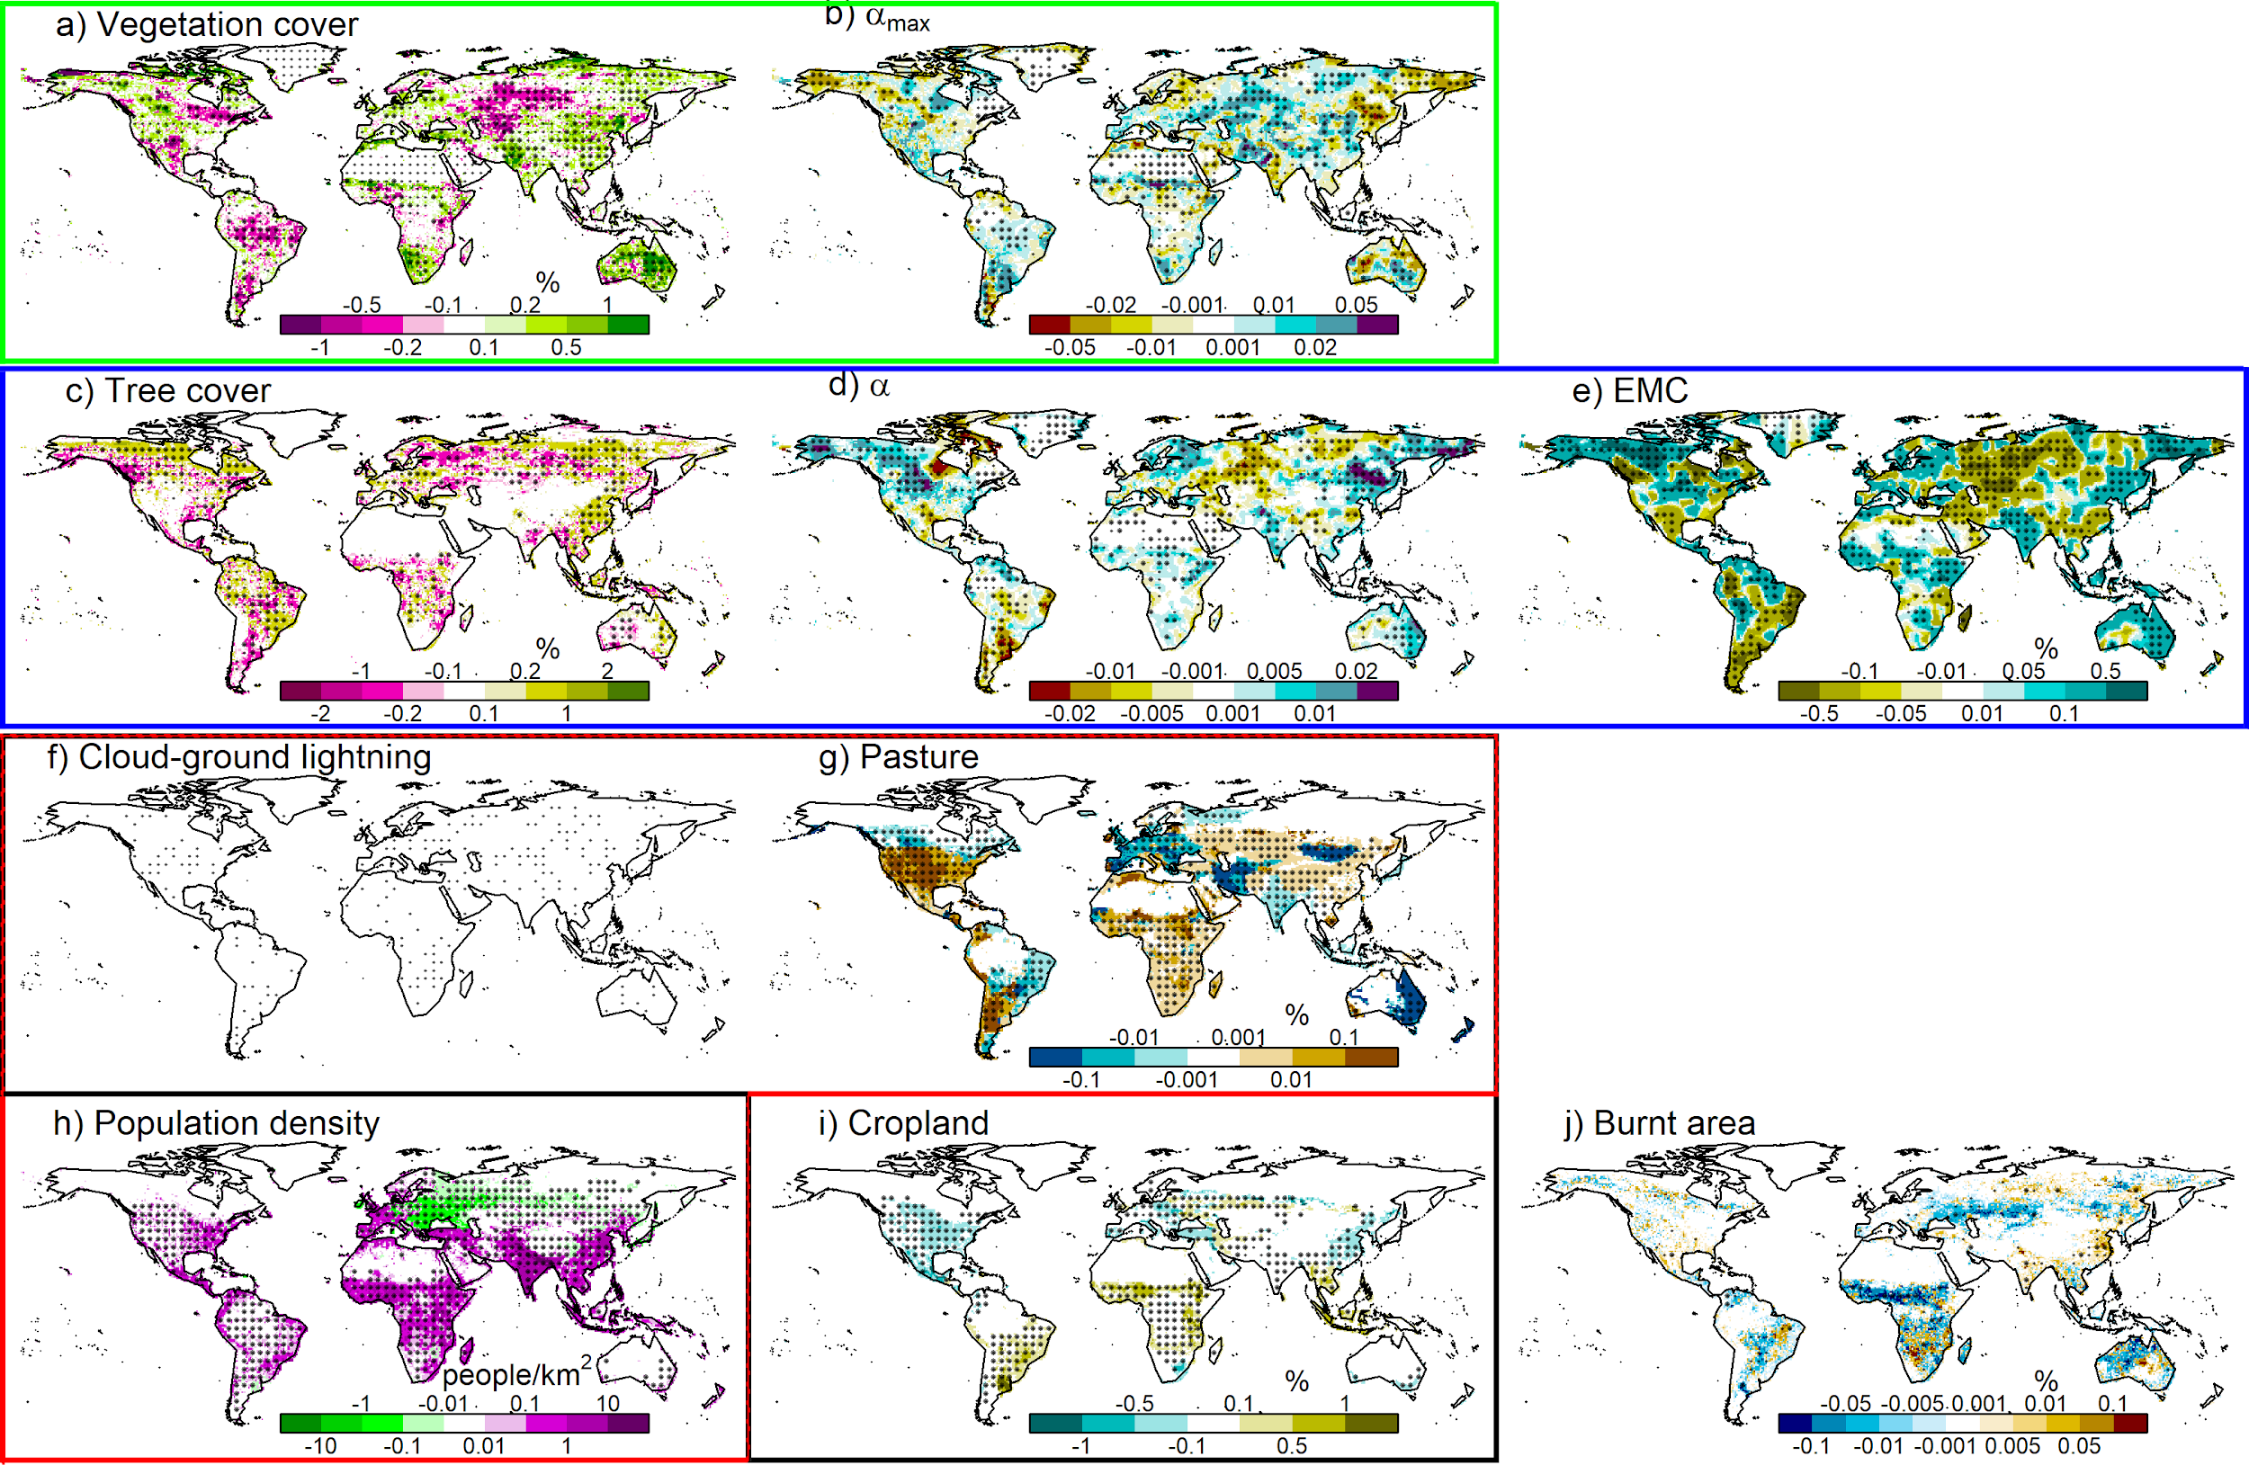

**Supplementary Figure** 2: **Mean annual trends for the variables used to reconstruct burnt area.** Using the same units as in Supplementary Fig. S1. Fitted using a simple linear model (equation 11 in methods). Dots show significance in trends, measured on $dx/dt$ in methods equation 8: light dots are where $0.01 < p-value < 0.1$, heavy dots where $p-value < 0.01$.

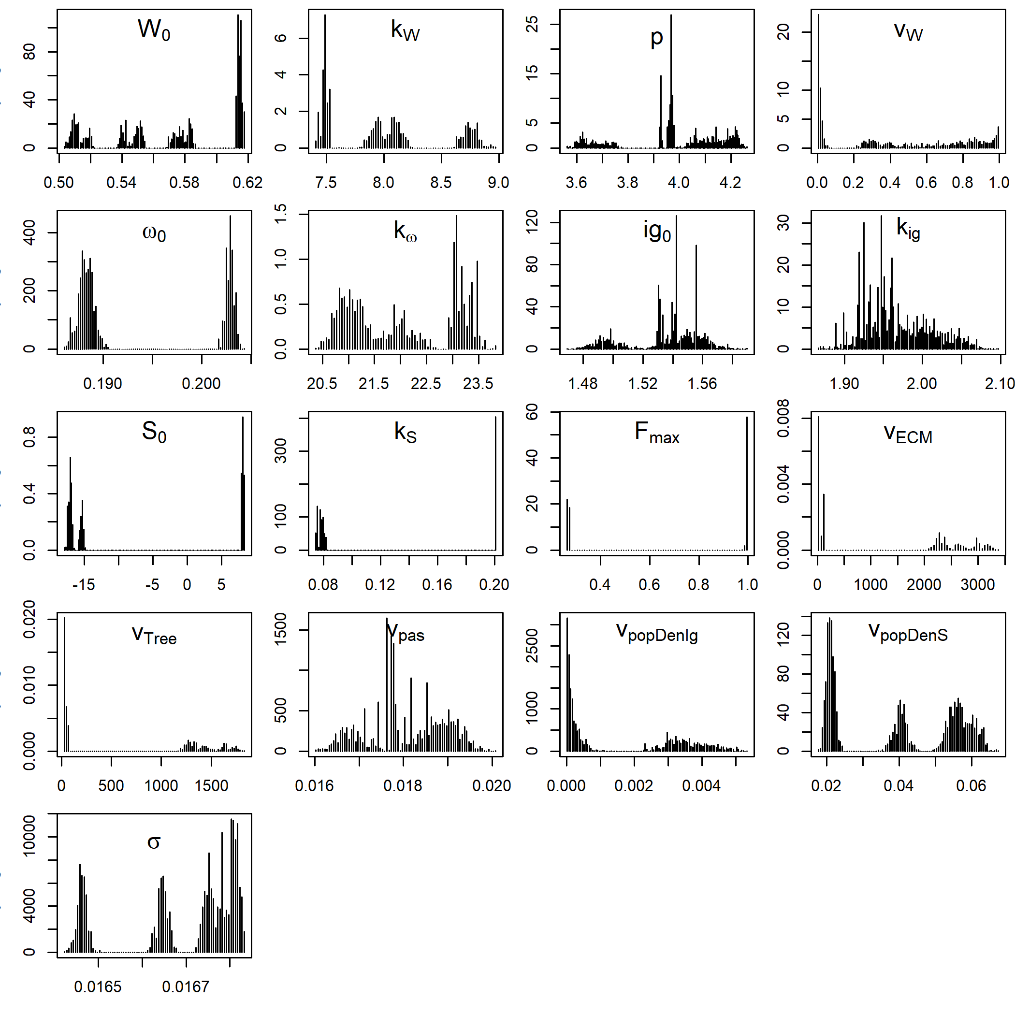

**Supplementary Figure 3:** **Probability distributions used to reconstruct burnt area and its controls**. Parameters are described in equations 1-3 in methods, obtained using the Bayesian inference technique outlined in equations 4-5 in methods. See methods for parameter definitions.

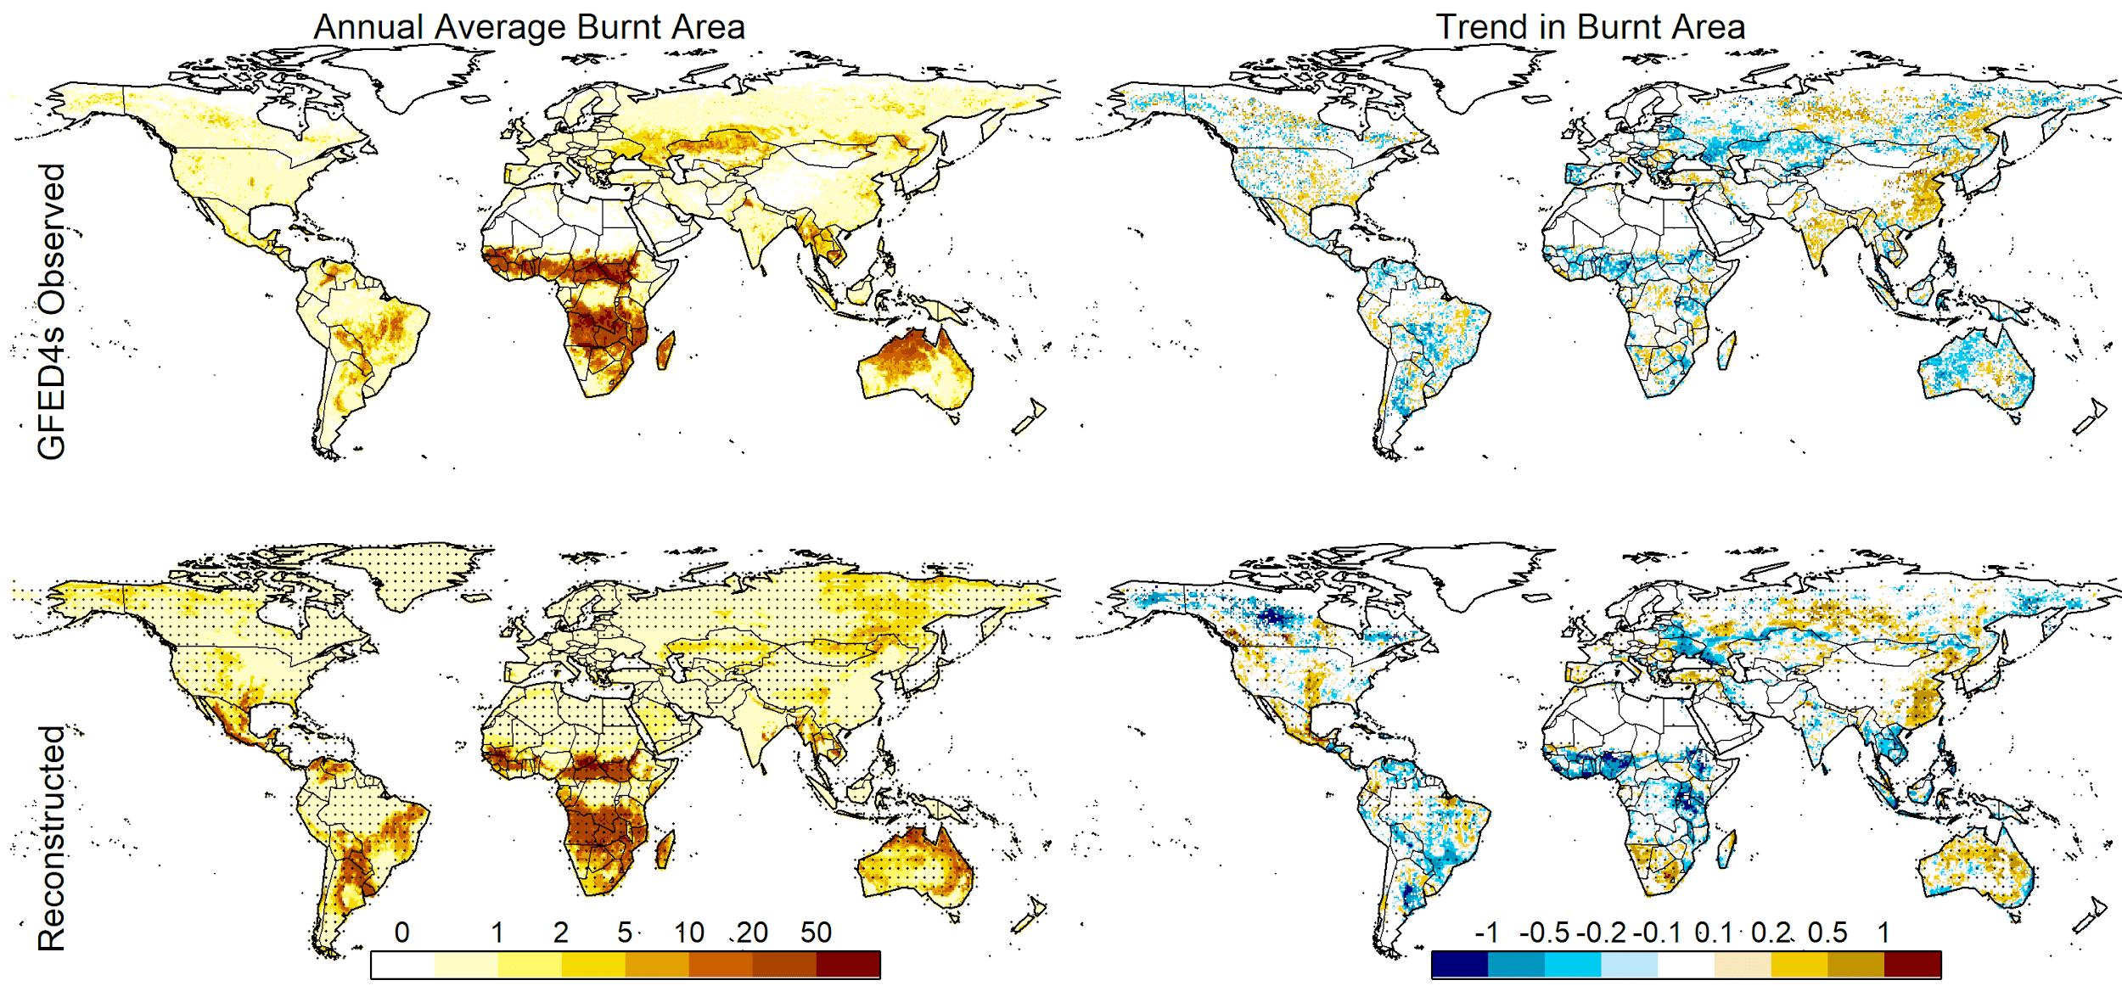

**Supplementary Figure 4: Comparison of reconstricted vs. observed burnt area.** 1st column shows annual % burnt area and 2nd column trends in burnt area for 2000-2014 for (top row) GFED4s observations and (bottom) reconstructed burnt area, with light hashing where showing 90% of ensemble members falling within 10% of the ensemble mean.

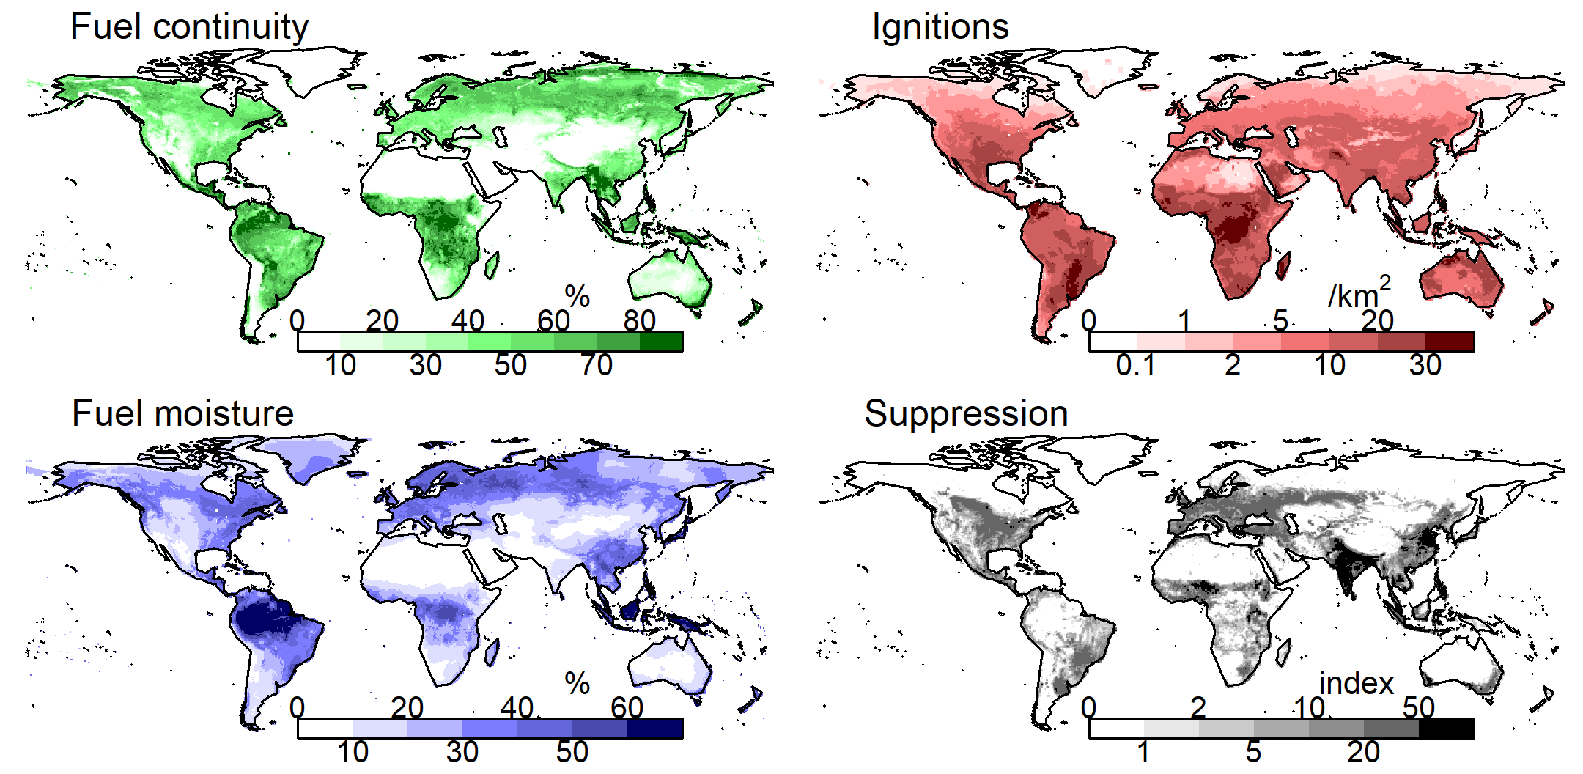

**Supplementary Figure 5: Mean monthly limitations on burnt area imposed by each control**. a) fuel continuity; b) fuel Moisture; c) ignitions; d) anthropogenic suppression. Colour shade shows mean monthly maximum burnt area allowed by a given control: light colours are areas where fire excluded, dark areas show constrained burning for that control.

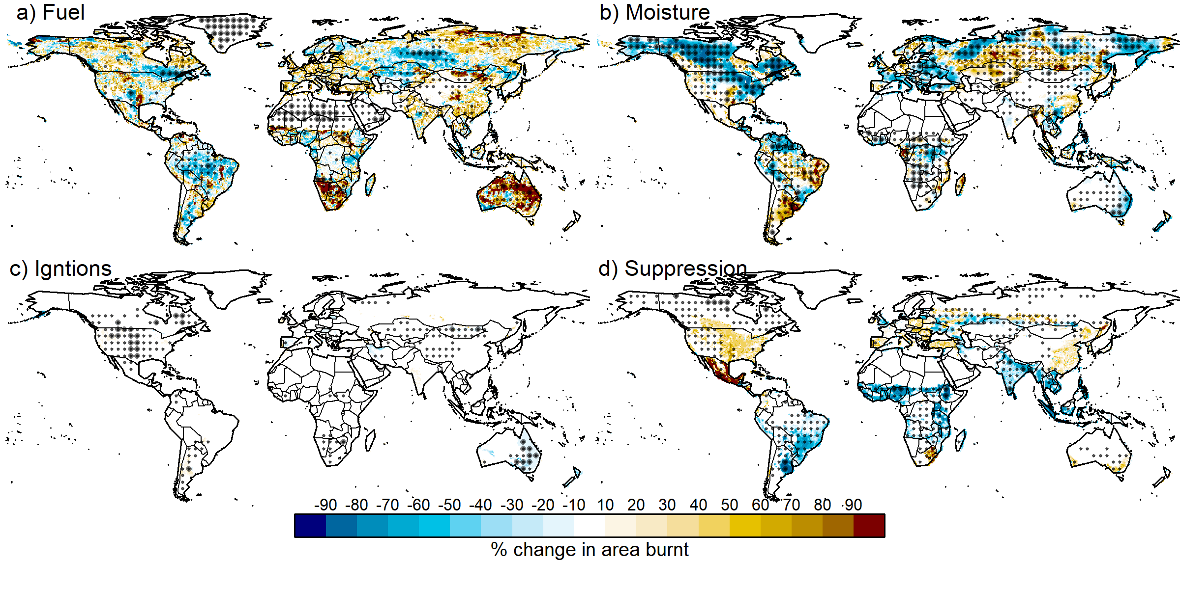

**Supplementary Figure 6: The impact of burnt area of each control between 2000-2014 as a percentage of the maximum possible change in burnt area.** a) fuel continuity; b) fuel Moisture; c) ignitions; d) anthropogenic suppression.See equation 12 in methods. Blue shows reductions in burnt area, yellow and brown increases.

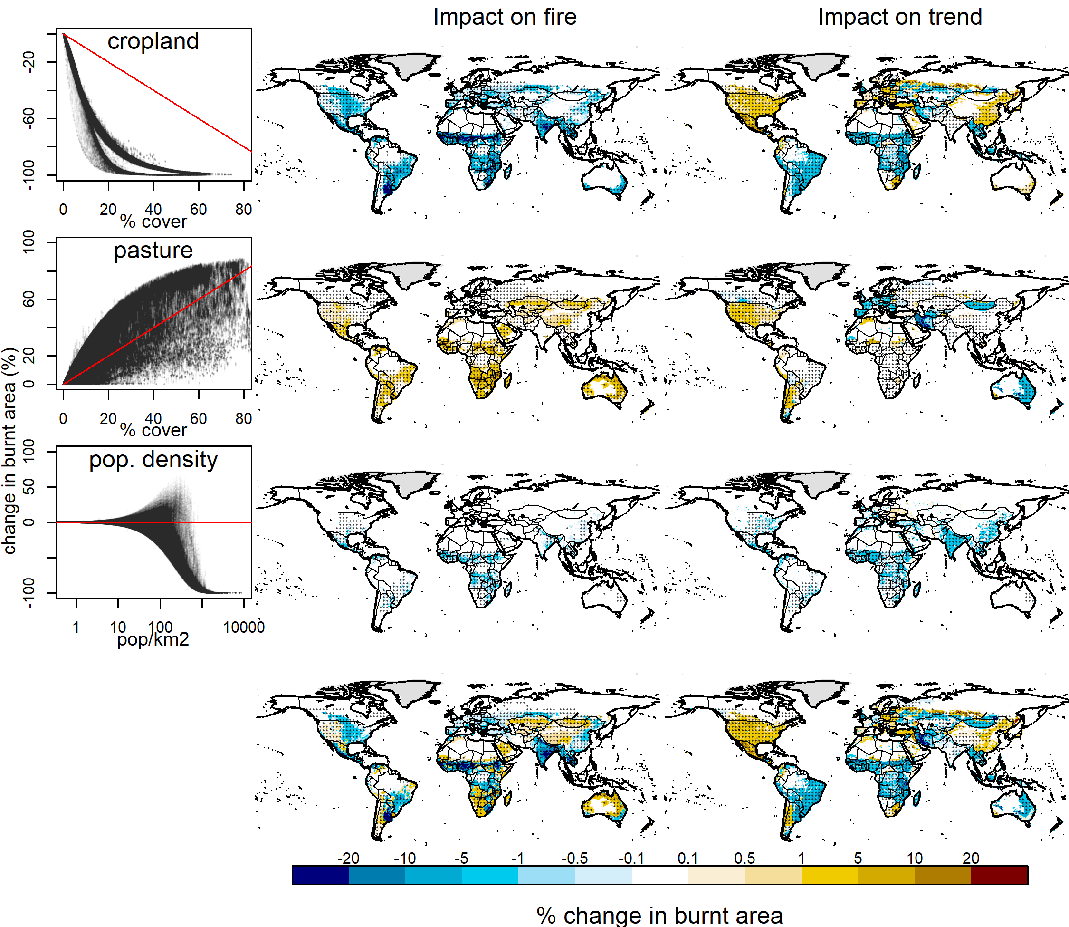

**Supplementary Figure 7**: **Cropland, pasture and population density impact on fire.** In the first column, the impact of each variable (x-axis) on burnt area (y-axis) is calculated as the difference in burnt area reconstruct with and without each variable. The annual average of this difference is mapped in the second column. The trend of each variable is the 3rd column is calculated as per equation 11-12 in methods, but with trends in each variable removed instead of an entire control.

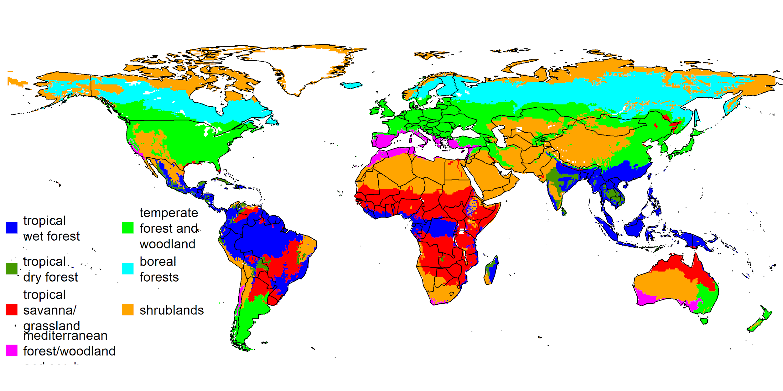

**Supplementary Figure 8**: **Ecosystems defined by grouping vegetation types from** [7](https://paperpile.com/c/JkHL33/HTFk)**.** Tropical wet forests are defined as tropical & sub-tropical wet broadleaf forest, tropical and subtropical coniferous forests in [7](https://paperpile.com/c/JkHL33/HTFk); tropical dry forest as tropical and sub-tropical broadleaf dry forest, tropical savanna/grassland as tropical and subtropical grasslands, savannas and shrublands, wooded grasslands & savannas; Mediterranean forest/woodland and scrub as Mediterranean forests, woodlands and scrub; temperate forest and woodland as temperate broadleaf and mixed forests, temperate grasslands, savannas & shrublands, temperate conifer forests; boreal forests as boreal forests/taiga; shrublands as montane grasslands and shrublands, tundra, deserts and xeric shrublands.

**Supplementary Table 1: Performance of reconstructed fire against burnt area observations**. Uses the metrics described by equation 6-8 in methods. Datasets are the same used in the fireMIP benchmarking protocol [8,9](https://paperpile.com/c/JkHL33/POow+Y3PA), with references given in the table. Scores are provided for the best (min), worse (max) and by score quantiles across our sampled posterior. Colouring follows [8](https://paperpile.com/c/JkHL33/POow) where, in this case, blue scores are better than all null models, and green is better than all but one.

|  |  |  |  |  |  |  |  |  |  |  |  |  |  |
| --- | --- | --- | --- | --- | --- | --- | --- | --- | --- | --- | --- | --- | --- |
| **Comparison** | **Metric** | **Step** | **Null Models** | | | | **Reconstructed fire score quantiles** | | | | | | |
| ***Median*** | ***Mean*** | ***Randomly Resampled*** | |
| ***Mean*** | ***Sd*** | ***Min*** | ***10%*** | ***25%*** | ***50%*** | ***75%*** | ***90%*** | **Max** |
| Model error | NMSE | 1 | 1.016 | 1 | 1.743 | 0.005 | 0.772 | 0.800 | 0.804 | 0.818 | 0.826 | 0.833 | 0.853 |
| GFED4s [6](https://paperpile.com/c/JkHL33/fQ08) annual average  2000-2014 | NME | 1 | 0.745 | 1 | 1.167 | 0.002 | 0.603 | 0.612 | 0.613 | 0.623 | 0.627 | 0.629 | 0.63 |
| 2 | 0.598 | 0.606 | 0.61 | 0.625 | 0.629 | 0.632 | 0.637 |
| 3 | 0.615 | 0.62 | 0.623 | 0.625 | 0.655 | 0.665 | 0.677 |
| MERIS [10](https://paperpile.com/c/JkHL33/gvZD)annual average  2006-2009 | 1 | 0.691 | 1 | 1.120 | 0.003 | 0.699 | 0.713 | 0.720 | 0.733 | 0.750 | 0.752 | 0.755 |
| 2 | 0.704 | 0.720 | 0.724 | 0.753 | 0.785 | 0.787 | 0.792 |
| 3 | 0.642 | 0.647 | 0.648 | 0.650 | 0.679 | 0.693 | 0.705 |
| MCD45 [11](https://paperpile.com/c/JkHL33/Pdlz) annual average  2001-2009 | 1 | 0.722 | 1 | 1.150 | 0.003 | 0.708 | 0.712 | 0.718 | 0.757 | 0.797 | 0.799 | 0.803 |
| 2 | 0.718 | 0.721 | 0.725 | 0.784 | 0.841 | 0.843 | 0.848 |
| 3 | 0.653 | 0.659 | 0.666 | 0.673 | 0.674 | 0.685 | 0.694 |
| GFED4s [6](https://paperpile.com/c/JkHL33/fQ08) trends  2000-2014 | 1 | 0.957 | 1 | 1.044 | 0.004 | 0.85 | 0.852 | 0.852 | 0.873 | 0.876 | 0.878 | 0.881 |
| 2 | 0.877 | 0.877 | 0.878 | 0.894 | 0.897 | 0.9 | 0.901 |
| 3 | 0.923 | 0.924 | 0.925 | 0.952 | 0.957 | 0.959 | 0.961 |

**Supplementary references**

1. [Daac, N. L. P. Vegetation Continuous Fields : MOD44B. (2015). doi:](http://paperpile.com/b/JkHL33/vhid)[10.5067/MODIS/MOD44B.006](http://dx.doi.org/10.5067/MODIS/MOD44B.006)

2. [Davis, T. W. *et al.* Simple process-led algorithms for simulating habitats (SPLASH v.1.0): robust indices of radiation, evapotranspiration and plant-available moisture. *Geoscientific Model Development* **10,** 689–708 (2017).](http://paperpile.com/b/JkHL33/SMGM)

3. [Kelley, D. I., Harrison, S. P. & Prentice, I. C. Improved simulation of fire–vegetation interactions in the Land surface Processes and eXchanges dynamic global vegetation model (LPX-Mv1). *Geoscientific Model Development* **7,** 2411–2433 (2014).](http://paperpile.com/b/JkHL33/zgKW)

4. [Cecil, D. J., Buechler, D. E. & Blakeslee, R. J. Gridded lightning climatology from TRMM-LIS and OTD: Dataset description. *Atmos. Res.* **135-136,** 404–414 (2014).](http://paperpile.com/b/JkHL33/hF0E)

5. [Klein Goldewijk, K., Goldewijk, K. K., Beusen, A., Van Drecht, G. & De Vos, M. The HYDE 3.1 spatially explicit database of human-induced global land-use change over the past 12,000 years. *Glob. Ecol. Biogeogr.* **20,** 73–86 (2010).](http://paperpile.com/b/JkHL33/eel1)

6. [van der Werf, G. R. *et al.* Global fire emissions estimates during 1997–2016. *Earth Syst. Sci. Data* **9,** 697–720 (2017).](http://paperpile.com/b/JkHL33/fQ08)

7. [Olson, D. M. *et al.* Terrestrial Ecoregions of the World: A New Map of Life on Earth A new global map of terrestrial ecoregions provides an innovative tool for conserving biodiversity. *Bioscience* **51,** 933–938 (2001).](http://paperpile.com/b/JkHL33/HTFk)

8. [Burton, C. *et al.* Representation of disturbance in the Joint UK Land Environment Simulator Vn4. 8 (JULES).](http://paperpile.com/b/JkHL33/POow)

9. [Rabin, S. S. *et al.* The Fire Modeling Intercomparison Project (FireMIP), phase 1: Experimental and analytical protocols. *Geoscientific Model Development* **20,** 1175–1197 (2017).](http://paperpile.com/b/JkHL33/Y3PA)

10. [Alonso-Canas, I. & Chuvieco, E. Global burned area mapping from ENVISAT-MERIS and MODIS active fire data. *Remote Sens. Environ.* **163,** 140–152 (2015).](http://paperpile.com/b/JkHL33/gvZD)

11. [Roy, D. P., Boschetti, L., Justice, C. O. & Ju, J. The collection 5 MODIS burned area product—Global evaluation by comparison with the MODIS active fire product. *Remote Sens. Environ.* **112,** 3690–3707 (2008).](http://paperpile.com/b/JkHL33/Pdlz)